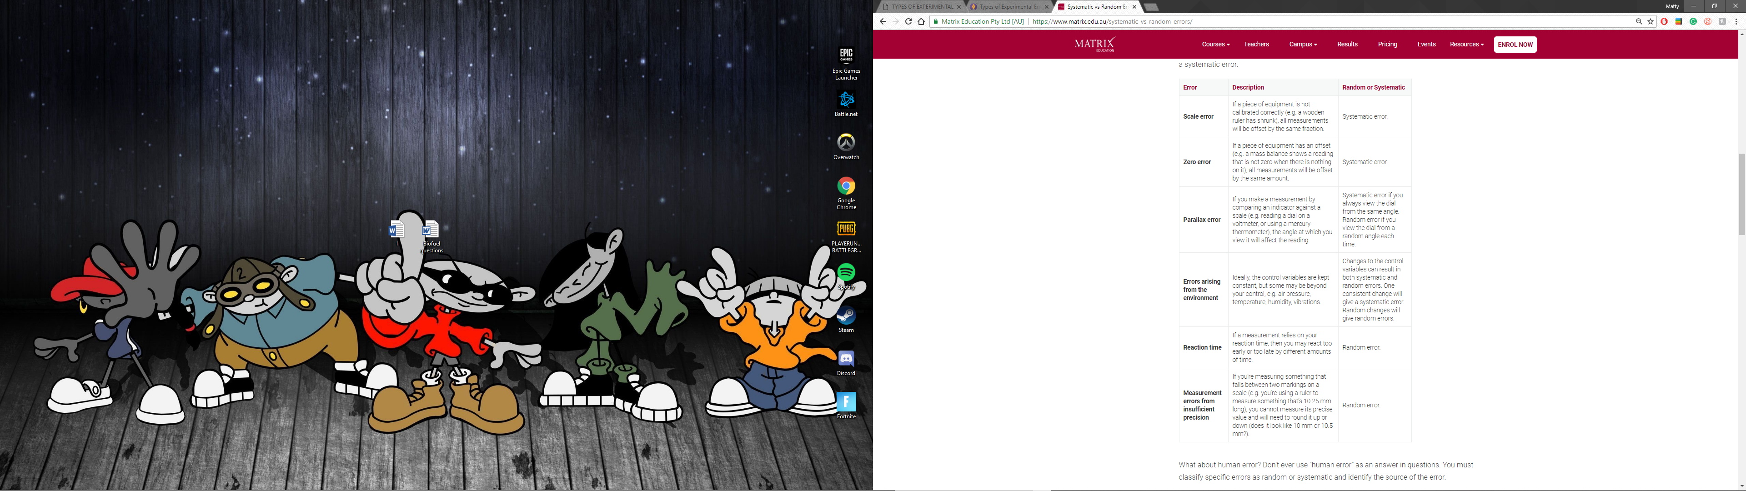

**Instrument drift** (systematic) - Most electronic instruments have readings that drift over time. The amount of drift is generally not a concern, but occasionally this source of error can be significant and should be considered.

**Zero offset** (systematic) — When making a measurement with a micrometer caliper, electronic balance, or electrical meter, always check the zero reading first. Re-zero the instrument if possible, or at least measure and record the zero offset so that readings can be corrected later. It is also a good idea to check the zero reading throughout the experiment. Failure to zero a device will result in a constant error that is more significant for smaller measured values than for larger ones.